Starwars People API

Development of API for SPS

1.- First step was “Test the swapi API in Postman”

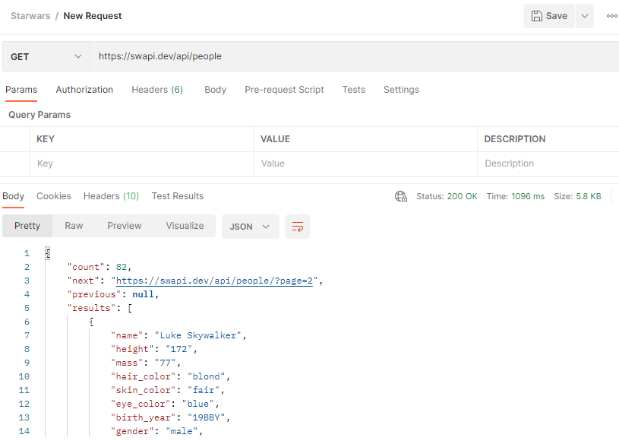

2.- Create the sample response using Dataweave Playground in order to test the transformation

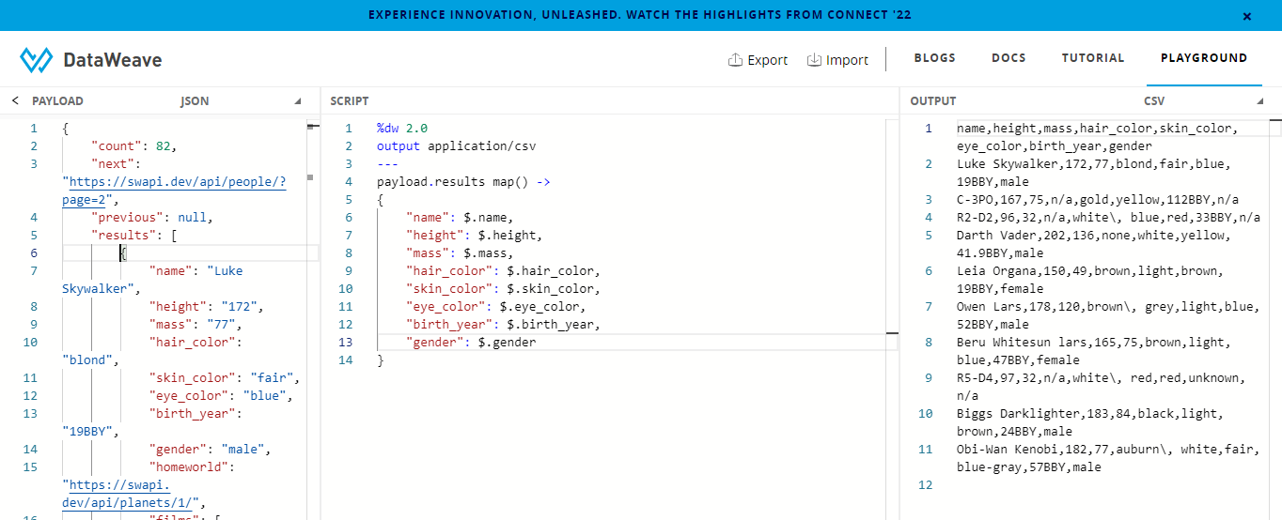

3.- Create raml for the API

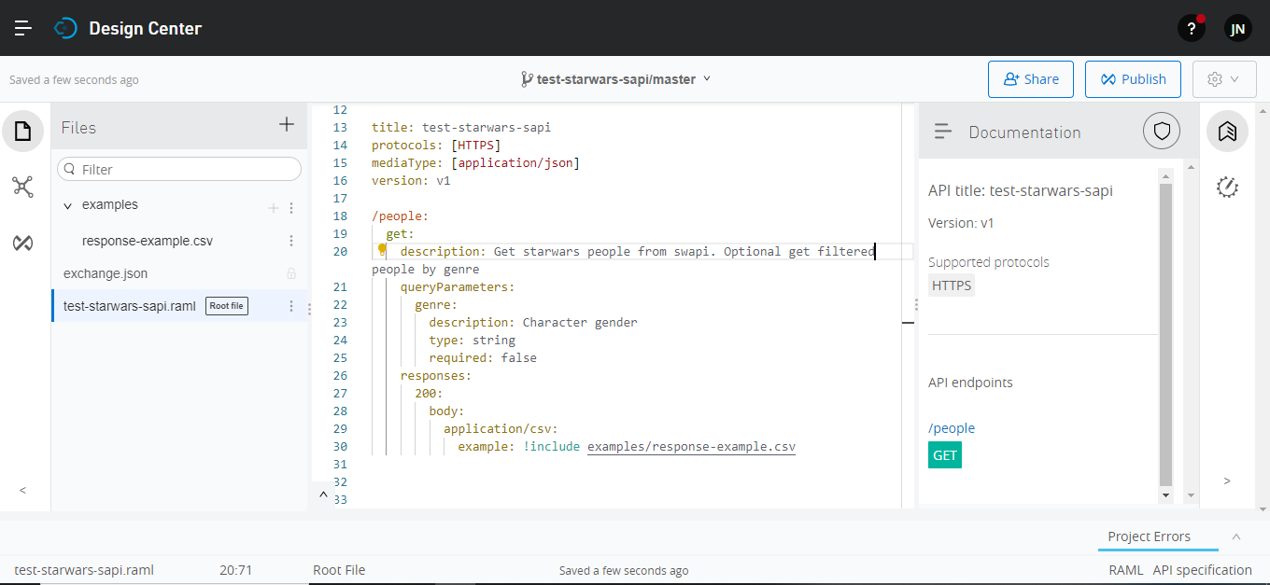

4.- Create the Mule project for the API

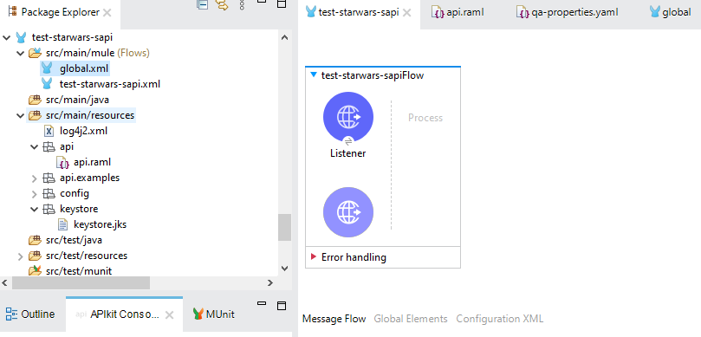

5.- Configure global connectors

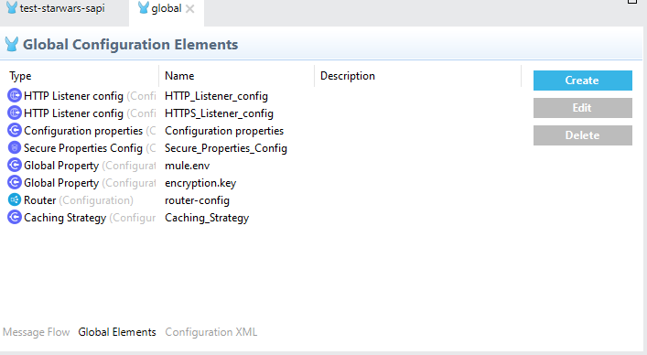

6.- Create the flow for get:\people. Cache was implemented in order to retrieve data faster. Time for cache was set in 2 minutes

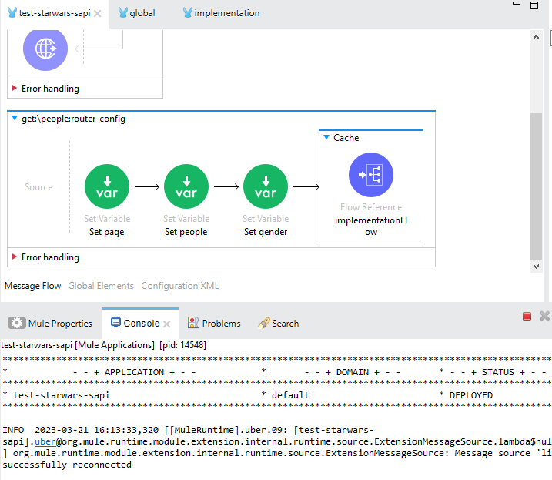

7.- Create the flow implementation

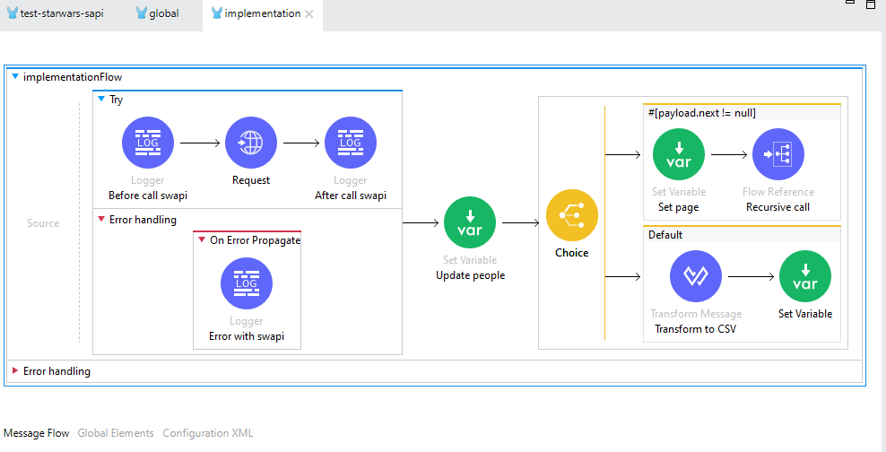

8.- Test the API using Postman

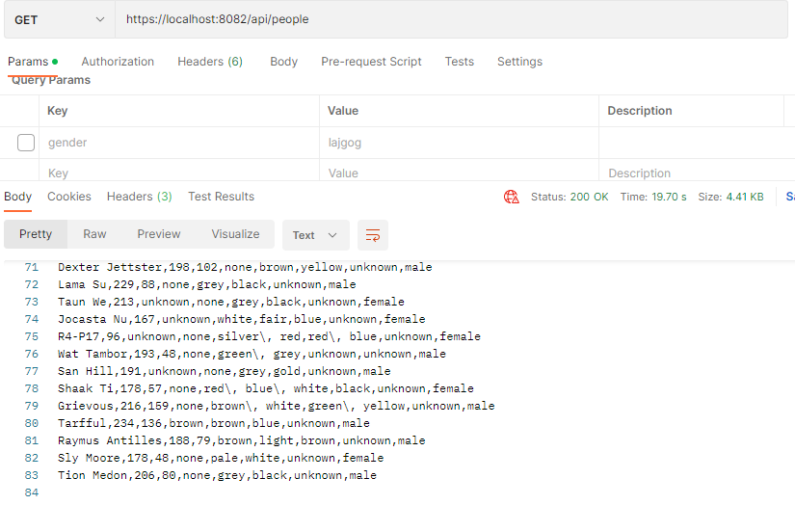

With gender queryParam

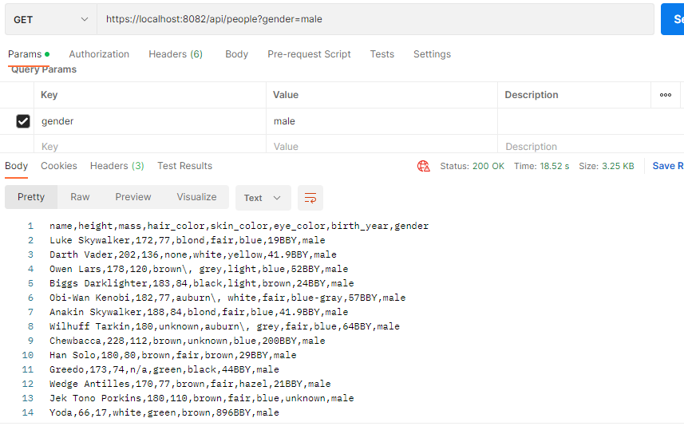

With Caché

